**LinkIt**

**Project Overview**

The LinkIt project aims to create a web application that allows users to create a personalized landing page with multiple links to their social media profiles, websites, blog posts, and other online content. This project provides users with a convenient way to share multiple links through a single URL, making it easier for their audience to discover and navigate their online presence. The project also allows user to manage passwords to various platforms with a secured platform.

**User-Friendly Interface:**

The website will have an intuitive, responsive, easy-to-navigate interface to improve user experience.

**User Requirements:** The user requirements for the LinkIt platform include the ability to register, log in, manage profile and links, add and edit links and passwords, and share a single link for multiple links.

**- User Registration**: Users should be able to register easily

using their email or social media accounts.

- **Link Management**: Streamlined process for adding, editing,

deleting links for different social media and other website

links.

- **Password Management**: Streamlined and Secure process for

adding, editing, deleting passwords for different platforms.

**System Architecture** The system architecture will be based on the MERN stack, comprising MongoDB for the database, Express for the back-end, React for the front-end, and Node.js for server-side scripting.

**Front-End** - Responsive and interactive user interface developed using React and Tailwind CSS for enhanced user experience.

**Back-End** - Efficient server-side scripting using Node.js and Express to handle requests and interactions with the database.

**Database** - Robust and scalable data storage and retrieval using MongoDB for effective management of orders and user data.

**Front-end Design** The front-end design will focus on creating an engaging, responsive, and easy-to-use interface for a seamless user experience.

**1. User Interface:** Designing a visually appealing and intuitive

user interface to enhance user engagement and

satisfaction.

**2. Responsive Layout:** Ensuring the website is accessible

and functional across various devices and screen sizes for

a consistent experience.

**3. Interactive Elements:** Implementing interactive features to

make the experience more dynamic and engaging.

**Back-end Design** The back-end design will prioritize efficient data processing and seamless interactions with the front-end.

**1. Register / Login:** Includes user authentication, account

management features, and user experience.

**2. Link/Password Management :** Includes efficient and secure

management of the links and passwords by the user.

.

**Database Design** The database design will focus on creating an organized structure for storing user data, profile information, links, and password records.

**Tech Stack:**-

1.Reactjs

2.Tailwind CSS

3.Expressjs

4.Nodejs

5.Mongodb

6.Mongoose

**Deployment** :- On Vercel

**Website Flow Diagram**

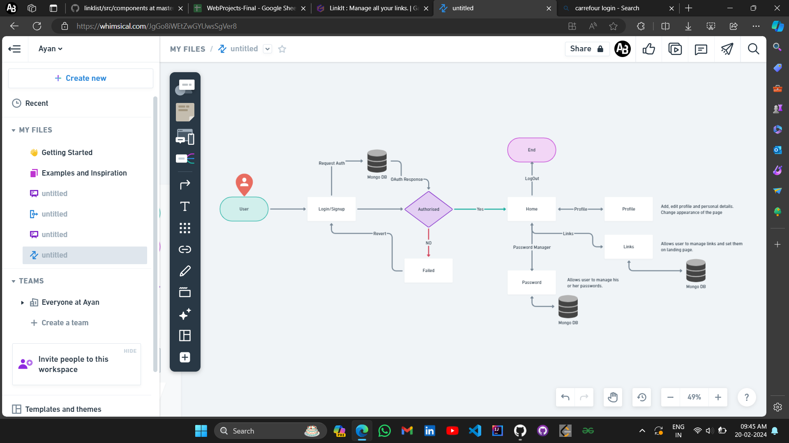

**Conclusion:**

In conclusion, the LinkIt website designed using the MERN stack aims to provide a seamless, and enjoyable experience for users. The detailed planning and design considerations will ensure the successful development and deployment of the website.